Hello Artem:

Please find below feedback on the sample data delivered on March 1st 2023

1. Feedback for Data Scraped
   1. Domain Scraped Field

The “Domain Scraped” Field information should be saved in Array format as mentioned in the “Guidestar NonProfit DataFields Needed_v1.xlsx” document.

For example see what was recorded for the nonprofit at <https://www.guidestar.org/profile/83-4387686> below and the fix.

|  |  |  |
| --- | --- | --- |
| What was recorded in the database | Correct Value | Notes |
| https://www.guidestar.org | {“ https://www.guidestar.org”} | See the “Guidestar NonProfit DataFields Needed_v1.xlsx” document for format guidance.  For this field, use only double quotes around individual data in arrays instead of one or two single quotes.  Also data should be encapsulated in curly braces as shown in the “Correct Value” column. |

* 1. Specific URL Scraped Field

The “Specific Url Scraped” information should be saved in Array format as mentioned in the “Guidestar NonProfit DataFields Needed_v1.xlsx” document.

For example see what was recorded for the nonprofit at <https://www.guidestar.org/profile/83-4387686> below and the fix.

|  |  |  |
| --- | --- | --- |
| What was recorded in the database | Correct Value | Notes |
| https://www.guidestar.org/profile/83-4387686 | {“https://www.guidestar.org/profile/83-4387686”} | See the “Guidestar NonProfit DataFields Needed_v1.xlsx” document for format guidance.  For this field, use only double quotes around individual data in arrays instead of one or two single quotes.  Also data should be encapsulated in curly braces as shown in the “Correct Value” column. |

* 1. “Phone number” Fields

All the phone number fields, need to follow the following guidance:

For PHONE - prefix the country code to all phone numbers. So "510 798 8512" should be saved in the database as "+1 510 798 8512". Please take note of the format. There are no dashes or brackets in the phone number. It is ok to also leave out spaces.

For example see what was recorded for the nonprofit at <https://www.guidestar.org/profile/83-4387686> below and the fix.

Please fix for both the phone number fields

* Primary Contact Phone
* Fundraising Contact Phone

|  |  |  |
| --- | --- | --- |
| What was recorded in the database | Correct Value | Notes |
| +1(334) 872-3332 | +1 334 872 3332 | For PHONE - prefix the country code to all phone numbers. So "510 798 8512" should be saved in the database as "+1 510 798 8512". Please take note of the format. There are no dashes in the phone number. It is ok to also leave out spaces. |

* 1. “Null” Fields

All fields with no data should be left empty

Do not save the text string “Null” to the database, if there is no data, just leave the column as empty. Null is not a string.

See the data scraped for the nonprofit - <https://www.guidestar.org/profile/88-3768005>

See the screenshot below the table too.

|  |  |  |
| --- | --- | --- |
| What was recorded in the database | Correct Value | Notes |
| “Null” |  | Do not save the text string “Null” to the database, if there is no data, just leave the column as empty. |

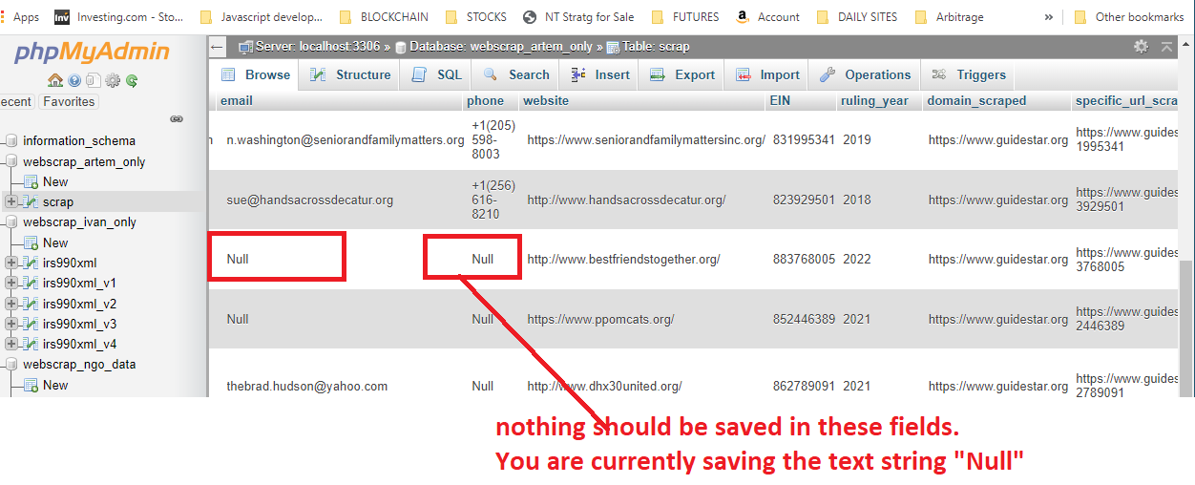

* 1. Handling “Mr.” and “Mrs.” In first name

Please disregard the title Mr. and Mrs. In identifying the name of a person.

If a name of a person is Mr. Morris Jolly or Mrs. Morris Jolly

The first name is “Morris”

The surname/last name is “Jolly”

Note- For the fullname please include the Mr. or Mrs. Title in the fullname.

Please fix for both the Primary Contact & Fundraising Contact Fields.

|  |  |  |
| --- | --- | --- |
| What was recorded in the database | Correct Value | Notes |
| Mr | Morris | If a name of a person is Mr. Morris Jolly or Mrs. Morris Jolly  The firstname is “Morris”  The surname/lastname is “Jolly” |

Thanks for the data delivery!

Please let me know if you have any questions.

Thanks,

Kolapo.